Activity sheet 4.4

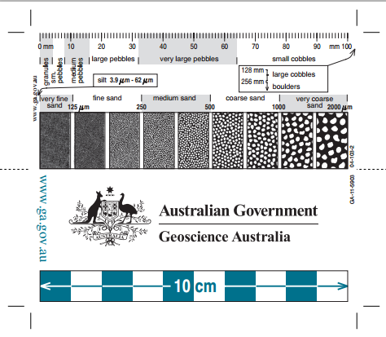

Grain size comparator
Grain size comparator

